Scenario: check windowhandles
Step: Launch "alertspage" WebPage - PASS
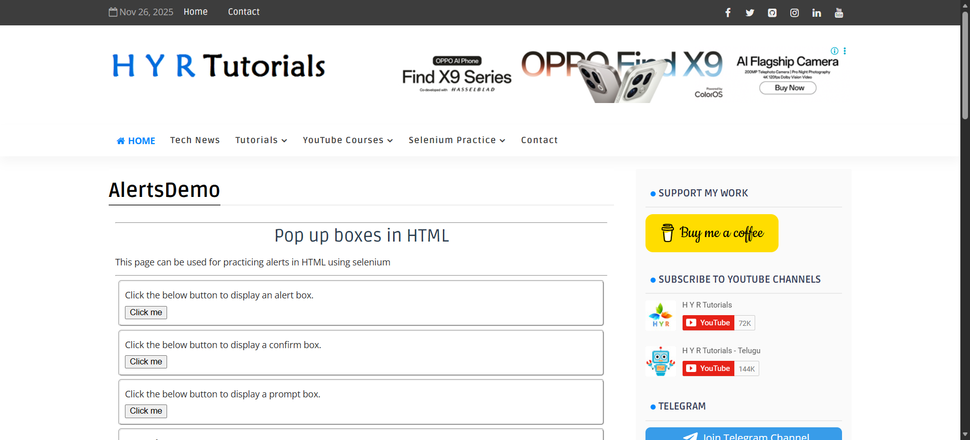
Step: User click the "click" element at "WHPage" page - PASS
Step: Then the user switches to alert and get text from alertbox - PASS
Step: Then the user switches to alert and enter"SUBBU" into alert box - PASS
Step: Then the user switches to alert and get text from alertbox - PASS
Step: Then the user switches to alert and click OK button - PASS
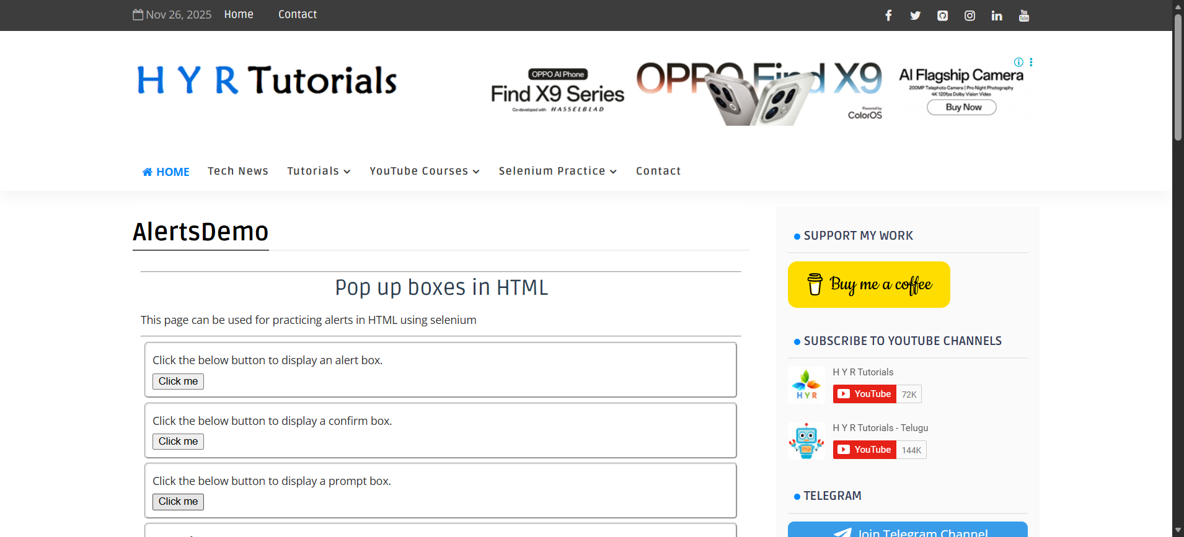
Step: And the user waits for "50" seconds - PASS
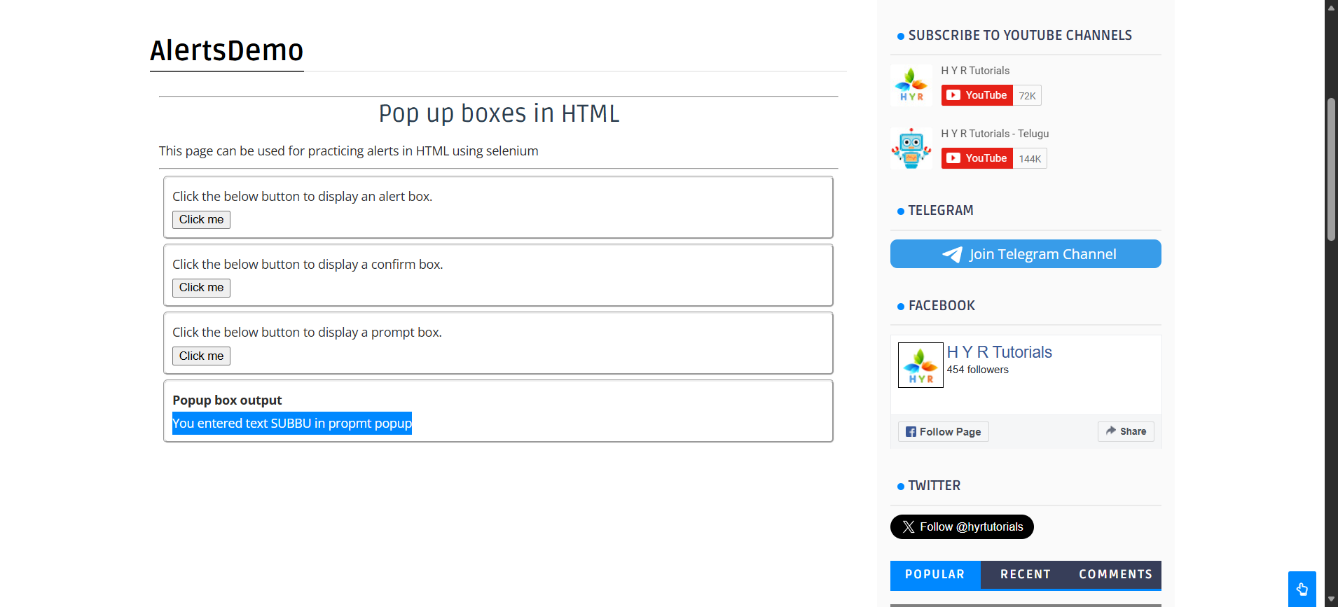
Execution Summary:
Total Steps: 7
Passed: 7
Failed: 0

